Lab 6 Part B

Zoe Boyle

1. 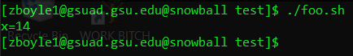
2. The script has a while that squares a number starting at 1 and increasing by one value after each iteration. The square of this number is added to the square of the last number. The while lasts until the third iteration and then prints the sum of the squares.
3. 
4. 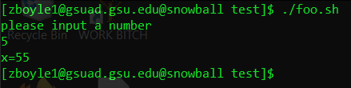
5. 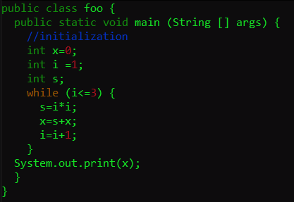
6. 
7. 
8. hello
9. 
10. 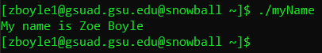

myName.c --

#include <stdio.h>

int main(void)

{

printf("My name is Zoe Boyle");

return 0;

}